Upper Stanislaus River Watershed Management Plan

Deliverable #1

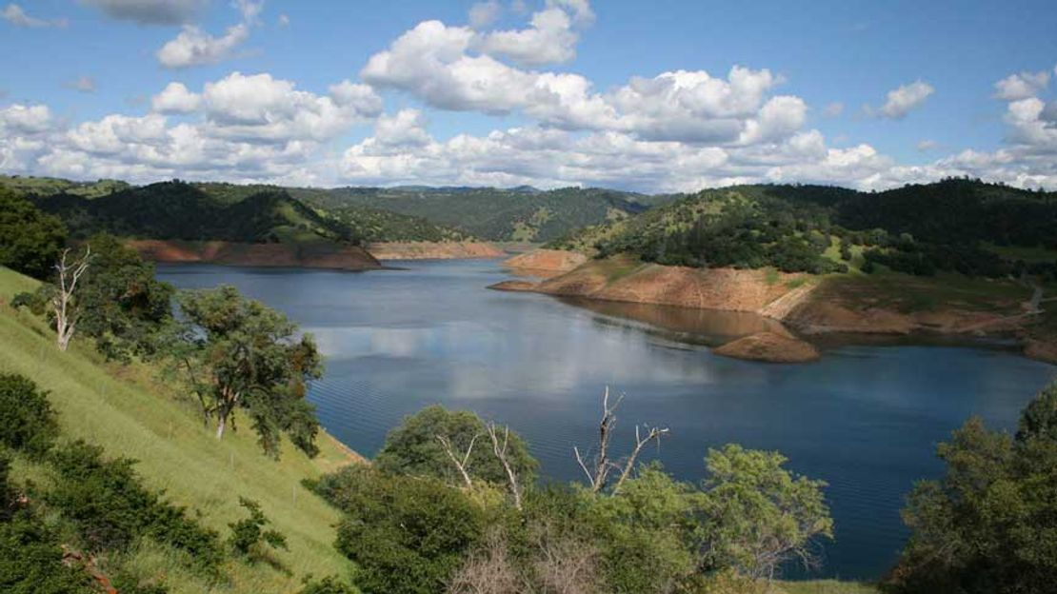

Alex Milward

Bren School of Environmental Science & Management

ESM 224 – Watershed Quality Analysis

Introduction

The purpose of this Watershed Management Plan (WMP) is to provide a holistic framework to address issues of water quality and ecological concern in the Upper Stanislaus River Watershed. A watershed management plan helps to identify the sources of impairment in a watershed, estimate quantifications of impairment and necessary load reduction, engage stakeholders, and develop a monitorable plan with timely milestones to restore watershed health. The Upper Stanislaus River Watershed is faced with two large, impaired reservoirs and impaired stretches of the Stanislaus River with no current state TMDLs. These waterbodies are impaired by pesticides, mercury, dissolved solids, and high water temperatures. Ranching and agricultural operations in the area has led to issues of non-point source pollution. This WMP aims to provide a structural framework to alleviate these issues.

Location

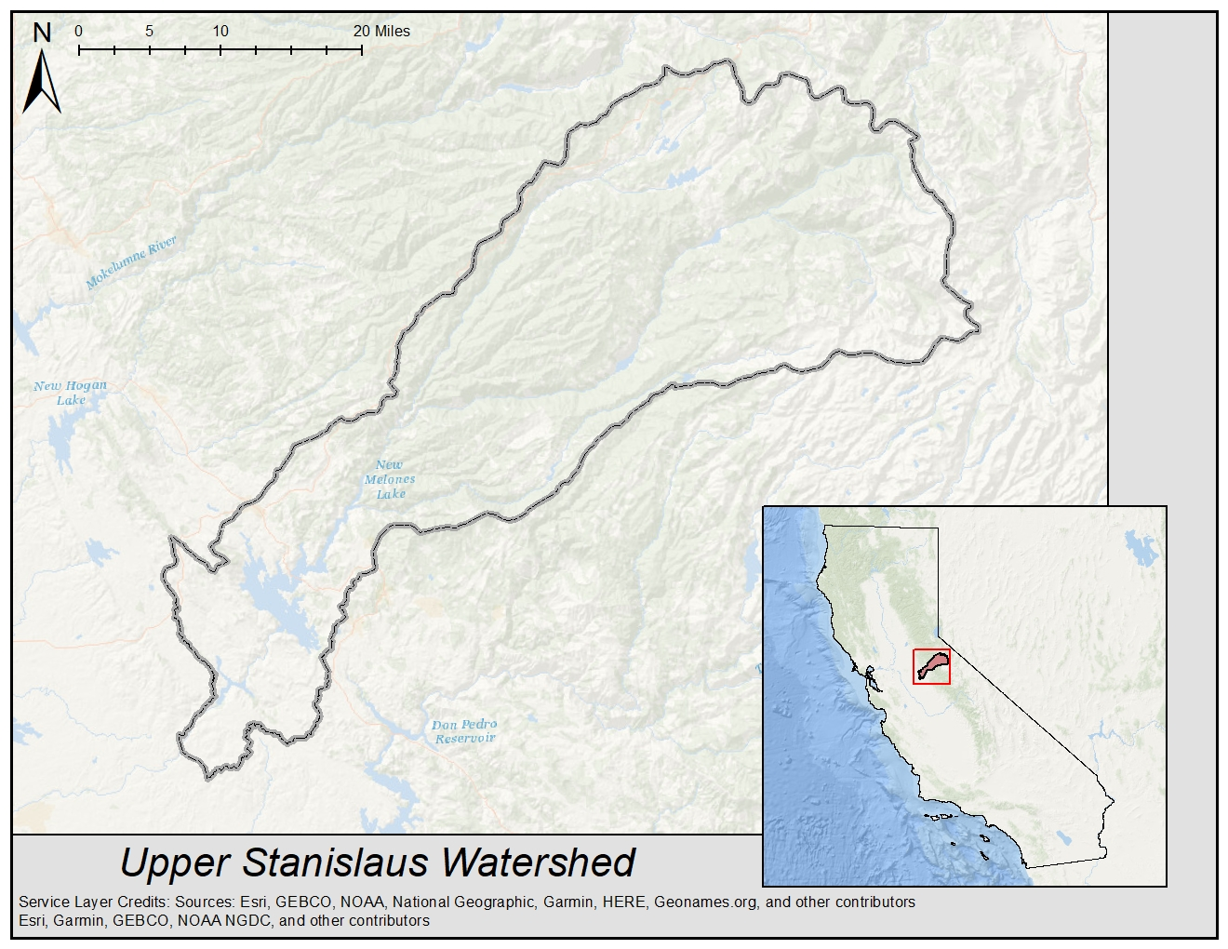The Upper Stanislaus River Watershed spans roughly 1,000 square miles of the Western slope of California’s central Sierra Nevada mountain range (**Figure 1.1**). The area includes the northern part of Tuolumne County, south-eastern part of Calaveras County, and southern tip of Alpine County and spans from rolling foothills in the southwest to high alpine peaks in the northeast. Water moves from northeast to southwest through the north, middle, and south forks of the Stanislaus River before converging into the main reach of the Stanislaus shortly before reaching New Melones Lake. The Stanislaus river eventually reaches the San Joaquin River as one of its largest tributaries.

**Figure 1.1 Location map of the Upper Stanislaus River Watershed.**

Topography

The landscape of the Upper Stanislaus Watershed varies dramatically from low to high elevation. The area slopes downward from the northeast to the southwest, with a peak elevation of 3,492 meters, or 11,457 feet above sea level, and a minimum elevation of just 61 meters, or about 200 feet above sea level (**Figure 1.2)**. Snow melt at these higher elevations feeds alpine lakes and the headwaters for the three major tributaries to the Stanislaus. The north, middle, and south forks of the Stanislaus River flow through deeply incised river canyons and mountainous terrain. At lower elevations, rolling foothills replace steep mountainsides as the river flows into diversion mechanisms for irrigation and other infrastructure for flood protection and hydroelectric power.

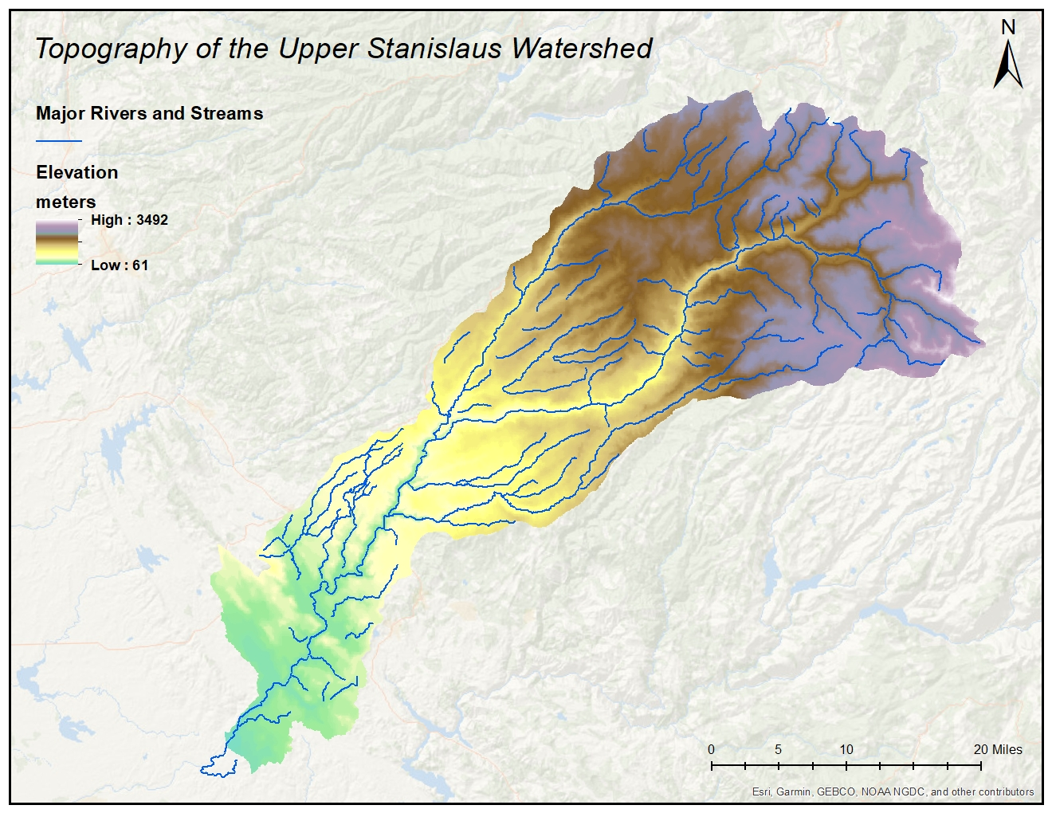**Figure 1.2 Topographic map of the Upper Stanislaus River Watershed.** High elevations are displayed in white/purple, mid elevations are displayed in light brown/yell, and low elevations are displayed in green. Major rivers and streams are shown in blue.

Climate

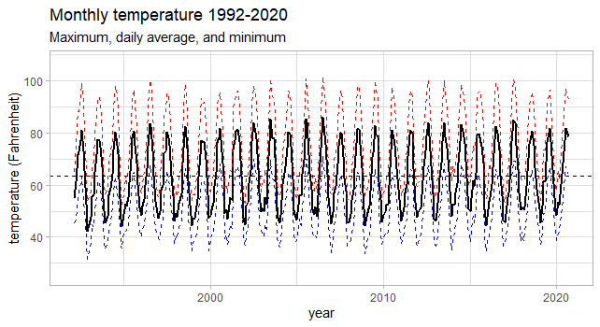The climate of the Upper Stanislaus Watershed varies with elevation. While the entire area experiences cold, wet winters and relatively warm, dry summers, there is extreme internal variation of each of these seasons between high sierra landscape and lower elevation foothills. Based on NOAA single station data at New Melones Lake, the average temperature from 1992 to 2020 for the watershed area is 63.37 degrees Fahrenheit, with high seasonal and diurnal fluctuations in temperature (**Figure 1.3(a)**).

**Figure 1.3(a) Monthly temperature variation from 1992 – present in degrees Fahrenheit**. Mean monthly temperature is represented by the solid black line, while mean monthly maximum and mean monthly minimum temperature are represented by the dashed red and blue lines, respectively. The mean temperature for the entire window of analysis is 63.37 °F. Data from: NOAA National Climatic Data Center, Station GHCND:USC00046174 – New Melones Lake, CA

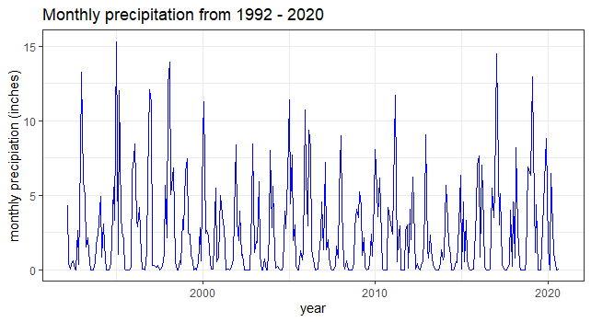Precipitation varies greatly across landscapes in the watershed, with the higher elevations receiving substantially more winter precipitation than the lower elevations, with a large portion falling as snow at the highest elevations. Temporal precipitation patterns for mid-low elevations are shown in **Figure 1.3(b)**, based on NOAA station data at New Melones Lake from 1992 – present. The majority of precipitation across the entire watershed falls between November and April, while the summer months are generally much drier. Spatial precipitation patterns for the watershed are shown in **Figure 1.3(c)**.

**Figure 1.3(b)** **Total monthly precipitation from 1992 to 2020 observed at New Melones Lake.** Precipitation varies greatly interannually as well as intra-annually, with peaks in the winter months. Data from: NOAA National Climatic Data Center, Station GHCND:USC00046174 – New Melones Lake, CA

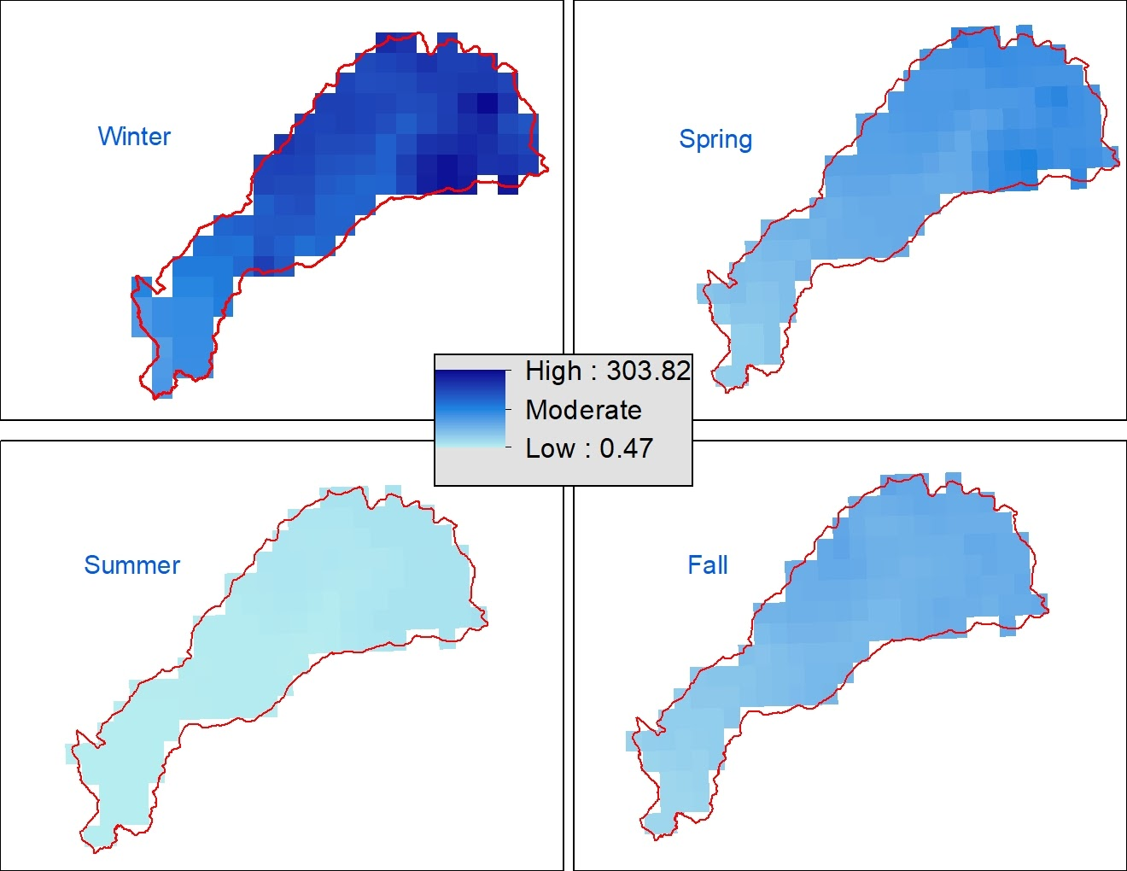

**Figure 1.3(c) Single month spatial distribution of precipitation in millimeters.** The majority of precipitation occurs in the winter (January), followed by spring (April), fall (October), and lastly summer (July). The northeastern side of the watershed tends to receive more precipitation than the southwestern side.

Soil Characteristics & Geology

The upper elevations of the Upper Stanislaus River Watershed is composed mostly of granitic rocks. The mountainous region was shaped through glaciation, leaving exposed granite rock with little soil and high runoff. Glacial and high sierra valleys host meadows and alpine lakes, where sediment accumulates, and the water table rises. The majority area of the well-drained surface soils, however, the steep westward slope prevents deep groundwater infiltration. Towards the foothills, clay-loam soils are dominant and contribute to high runoff towards New Melones Lake and Tulloch Reservoir. These areas are prone to non-point source pollution from cattle and livestock facilities. Detailed spatial representation of dominant hydrologic soil groups and infiltration capacity is shown in **Figure 1.4(a)**.

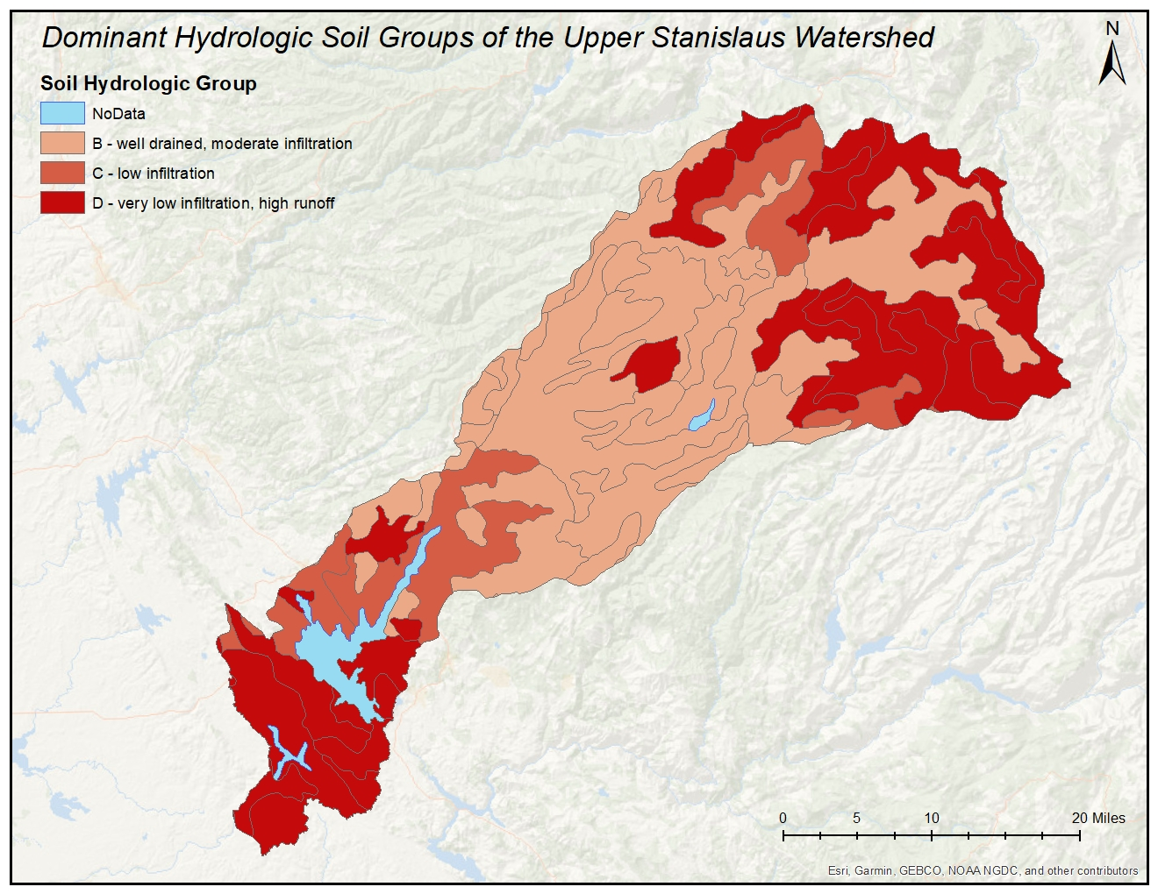

**Figure 1.4(a) Map of dominant hydrologic soil groups.** High runoff areas are seen in the high sierra and lower foothills, while the majority of the mid-upper elevations are composed of well drained, moderate infiltration capacity, soils.

Soil erodibility in the watershed also varies across the landscape, with the majority of highly erodible soils centered in the upper and lower foothills (mid to low elevation). Soil erosion contributes to sediment and other pollutant transport. Much of this is related to the road system in a highly forested area, as drainage from impervious roadways can contribute excess flows to soils already prone to erosion, resulting in impaired surface water quality. Soil erodibility (K Factor) is visualized below in **Figure 1.4(b)**.

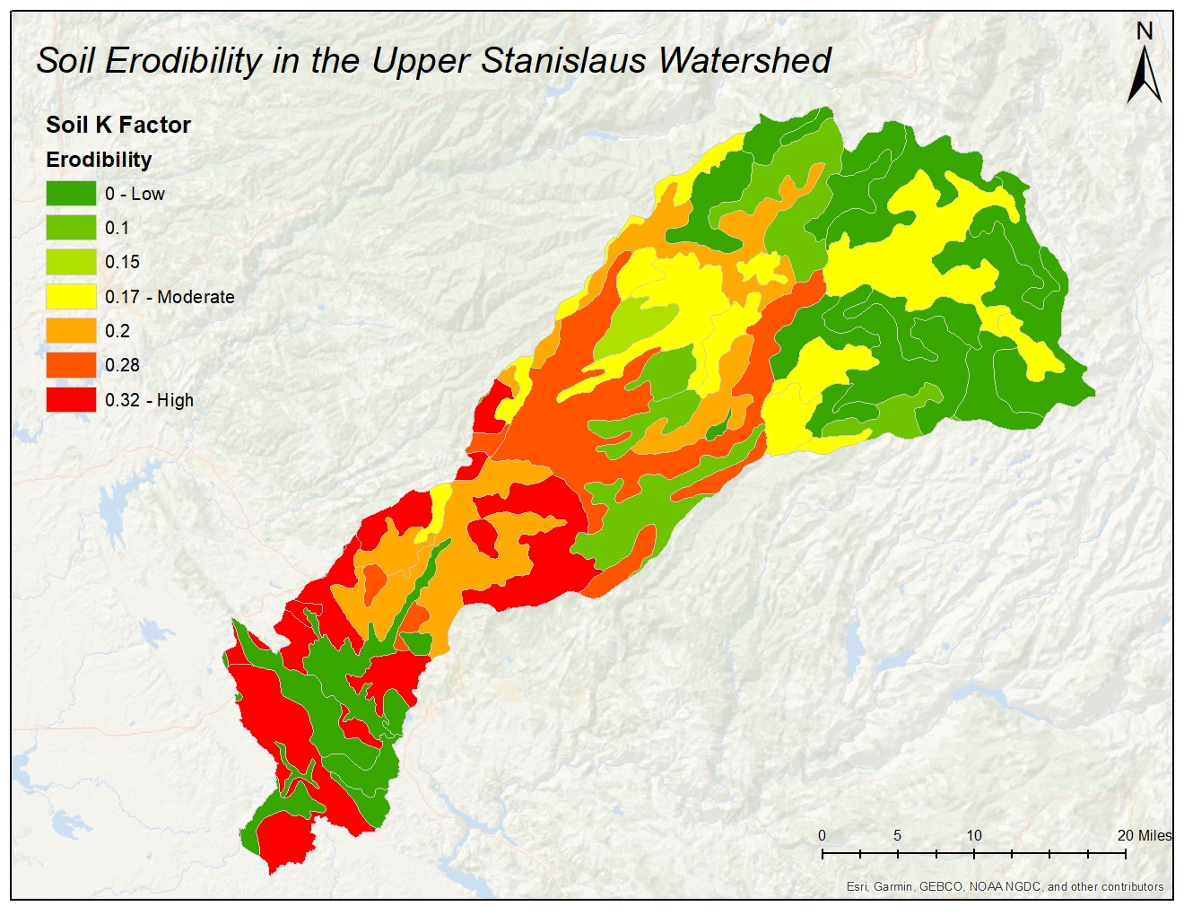

**Figure 1.4(b) Soils of the Upper Stanislaus Watershed by erodibility (K Factor).** K factor indicates susceptibility of soil to erosion and the rate of runoff. Low erodibility soils are concentrated in the upper elevations as well as around foothill lakes. High erodibility soils are seen in the mid-elevations and foothill areas away from waterbodies.

Hydrology

Surface and shallow subsurface flow of the Upper Stanislaus River Watershed flows from the northeast to the southwest foothills and eventually to California’s lower San Joaquin Valley. The highly sloped watershed and moderately slow soil infiltration rates means most of the flow is surface flow, with very little deep groundwater **(Figure 1.5)**. The headwaters of the north, middle, and southern forks of the Stanislaus are high sierra lakes and creeks that are the result of snowmelt. The middle fork and north fork converge in the central part of the watershed, followed by convergence with the south fork just above New Melones Lake. The Stanislaus river runs into New Melones Lake, through New Melones Dam, and into Tulloch Reservoir at the end of the watershed. New Melones Lake and Tulloch Reservoir are both designated for commercial and sport fishing uses. The Stanislaus River itself is designated for cold freshwater habitat, municipal and domestic water supply, non-contact water recreation, warm freshwater habitat, and water contact recreation.

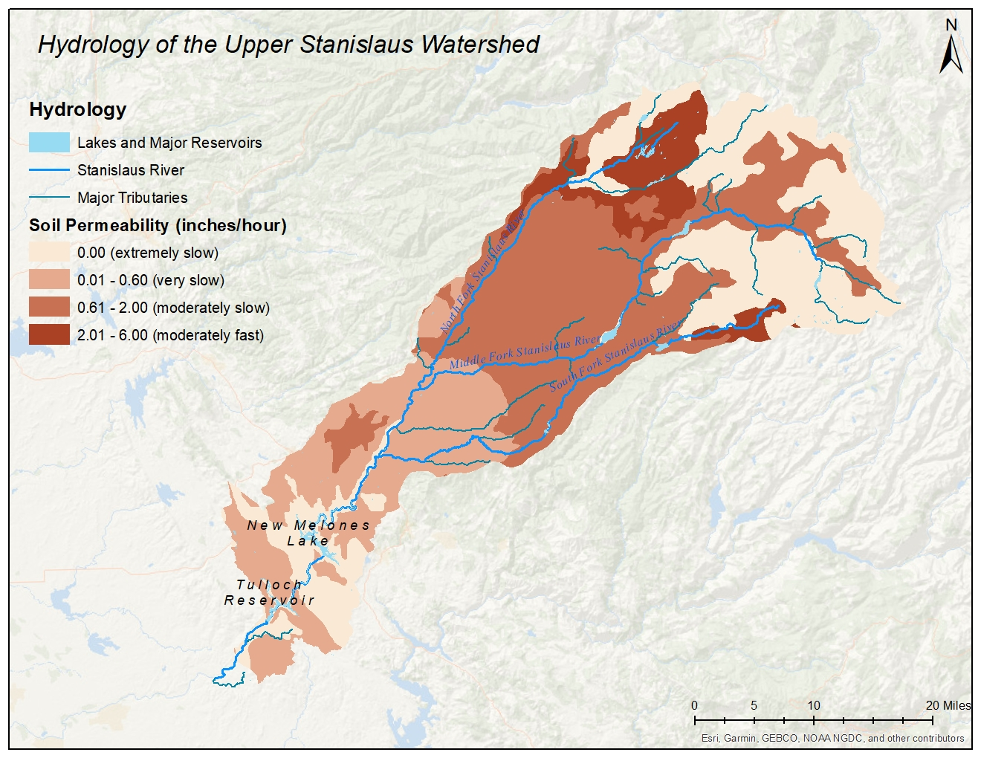

**Figure 1.5 Hydrology map showing the Stanislaus River (dark blue), major tributaries (blue-green), and lakes and major reservoirs (light blue).** Rivers are overlaid on soil permeability to visualize the extent of surface water transport down the watershed.

Land Use

The majority of land use in the Upper Stanislaus River Watershed is coniferous forest. These forests are managed by federal agencies with a small portion leased or owned by private users for resource extraction. Rangeland dominates the southwestern part of the watershed, mostly in the form of large ranches and privately owned land. Corridors of residential areas exist along the main stretch of highway running along the northern edge of the boundary. **Figure 1.6** below provides spatial reference for land use in the area.

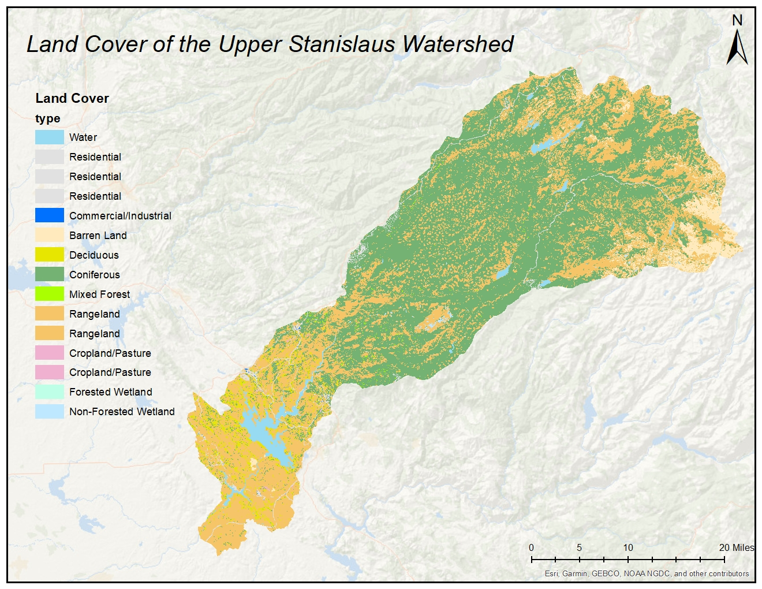

**Figure 1.6 Land use map of the Upper Stanislaus River Watershed**. The northeastern portion is dominated by coniferous forests, while the southwestern side is dominated by rangeland.

Biological Assets

The Upper Stanislaus River Watershed , along with much of the surrounding area, provide important habitat for important species, both terrestrial and aquatic. River flow impairment and diversions has prevented Chinook Salmon from reaching historic spawning grounds on the middle and southern forks of the Stanislaus River. However, the US Department of Fish and Wildlife annually stocks lakes in the area with Rainbow (pictured below) and Brown Trout.

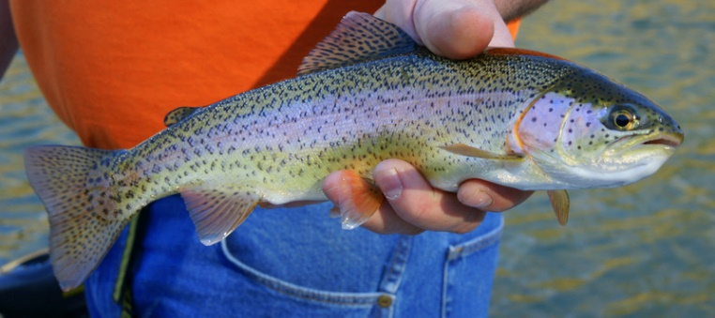

Rainbow Trout (*Oncorhynchus mykiss*)

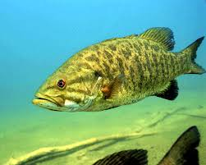The area is home to a number of important native species, many of which are listed as threatened, endangered, or vulnerable. Species in this watershed include Mule deer, Black bears, a number of bat species, and river otters. These species have to compete with non-native species, mostly aquatic as a result of fish plantings, such as the Smallmouth bass.

Smallmouth Bass (*Micropterus dolomieu)*

Summary

The first section of this preliminary watershed management plan includes general geographical information, such as location and topographic maps, climate data and time series trends, including temperature and precipitation patterns, as well as geologic, hydrologic, and land use maps and information as they pertain to water quality concerns and the transport of pollutants. Lastly, included in this section is a brief explanation of the biology of the area and the threats thereof - mostly invasive species and river flow impairment.

Understanding the geographic region presented here and the variation in climate, topography, and land use is crucial in understanding how to manage the watershed in a way that will be helpful in removing New Melones Lake, Tulloch Reservoir, and parts of the Stanislaus River off of the CWA Section 303(d) list.

References

*Biology 314—Sierra Nevada, pages 69-94*. (n.d.). Retrieved October 23, 2020, from <http://web.sonoma.edu/users/c/cannon/bio314chapter4_part2.html>

*Official Series Description—SIERRA Series*. (n.d.). Retrieved October 23, 2020, from <https://soilseries.sc.egov.usda.gov/OSD_Docs/S/SIERRA.html>

*Soils & Geology.* (2020). University of California Sierra Foothill Research and Extension Center. Retrieved October 23, 2020, from <http://sfrec.ucanr.edu/Data/Soils>

*Tuolumne-Stanislaus Integrated Regional Water Management Plan*. (2013). Kennedy/Jenks Consultants. Retrieved October 23, 2020, from <https://www.tudwater.com/wp-content/uploads/2013/02/Sec2_T-S-RegionDescription_021313_w-TRK.pdf>

*Stanislaus River*. (2020). Water Education Foundation. Retrieved October 23, 2020, from <https://www.watereducation.org/aquapedia/stanislaus-river>

*Tuolumne-Stanislaus IRWM*. (n.d.). Sierra Water Workgroup. Retrieved October 23, 2020, from <http://www.sierrawaterworkgroup.org/tuolumne-stanislaus-irwm.html>

*Waterbody Quality Assessment Report | Water Quality Assessment and TMDL Information | US EPA*. (n.d.). Retrieved October 23, 2020, from <https://ofmpub.epa.gov/waters10/attains_waterbody.control?p_au_id=CAR5342206320020701114625&p_cycle=2016&p_state=CA&p_report_type=>

*A Quick Guide to Developing Watershed Plans to Restore and Protect Our Waters*. (2020). United States Environmental Protection Agency. Retrieved October 23, 2020, from <https://www.epa.gov/sites/production/files/2015-12/documents/watershed_mgmnt_quick_guide.pdf>